Practical - 2
Practical Title: Semantic HTML5 Pages with Accessibility-Ready Structure

Problem Definition: Develop static HTML5 skeletons for at least 10 StudentHub pages such as Home, About, Register, Login, Dashboard, Events, Profile, Contact, Admin, FAQ, and Feedback. Use semantic tags and accessibility-friendly structure.

Theory

Are semantic tags such as header, nav, main, section, article, aside, and footer used properly?
Answer: Yes, Semantic HTML tags are used to organize the webpage into meaningful sections, making the code more structured and easier to understand.

2.Are form labels, headings, image alt text, and navigation links accessible?
Answer: Yes. Proper labels, headings, image alt attributes, and clear navigation links are used to improve accessibility and enhance the user experience.

3. Is the page structure consistent across all pages?
Answer: Yes. All pages follow a consistent layout with a similar header, navigation, content section, and footer, ensuring a uniform design throughout the website.

Implementation

Made StudentHub portal html pages using these tags :
header – Website header
nav – Navigation menu
aside – Sidebar
main – Main page content
section – Groups related content
div – Layout container
a – Navigation links
form – Login/Register forms
input – User input fields
button – Buttons
table, tr, th, td – Attendance and Results tables
img – Profile images and logos
footer – Footer section

Evidence of Work (Screenshots)
Figure 1.1 Index.html
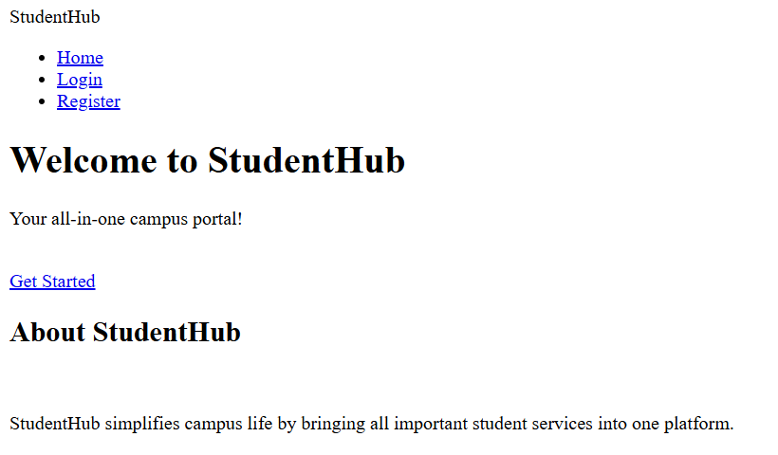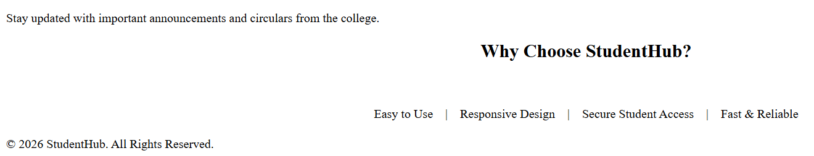
Description: Home page of website

Figure 1.2 login.html
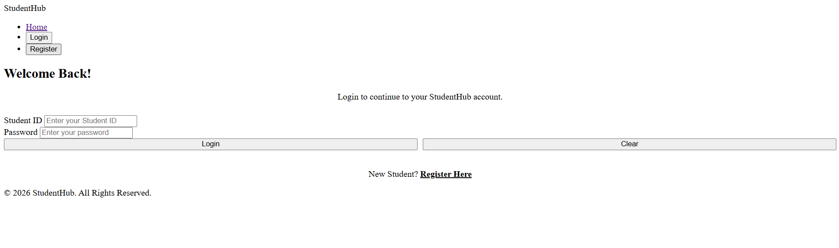
Description: login page for registered users

Figure 1.3 register.html
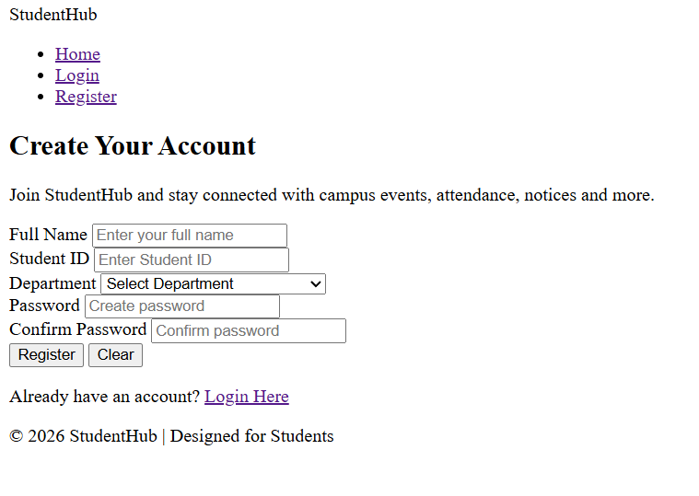
Description: Register page for new users
Figure 1.4 Dashboard.html
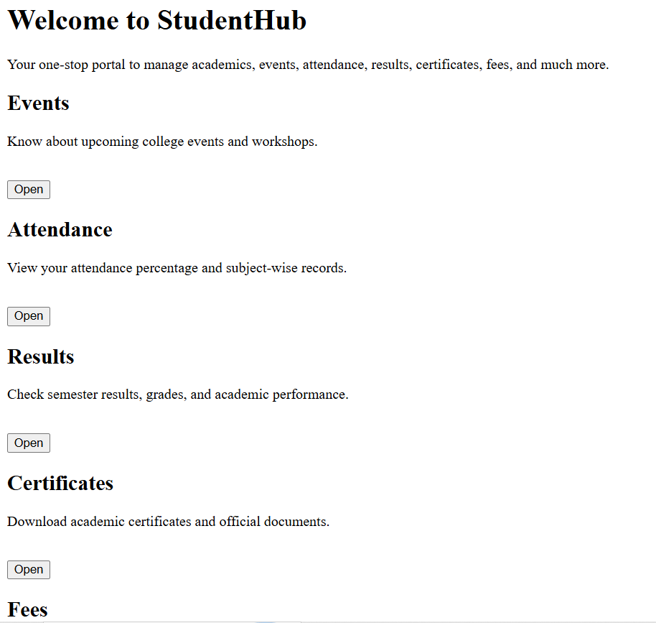
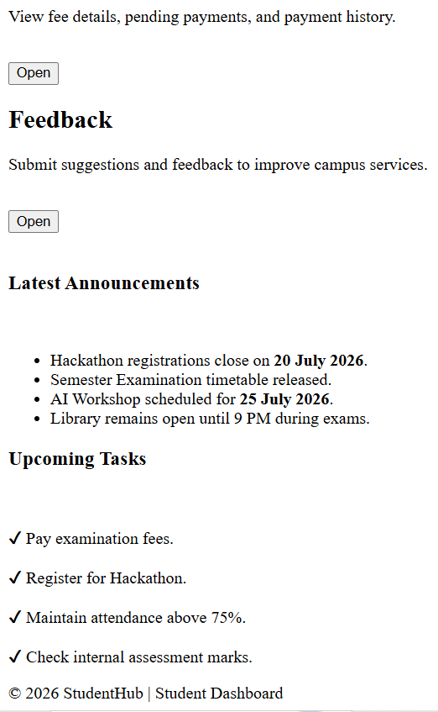
Description: Html page for dashboard when user successfully logs in

Figure 1.5 Attendance.html
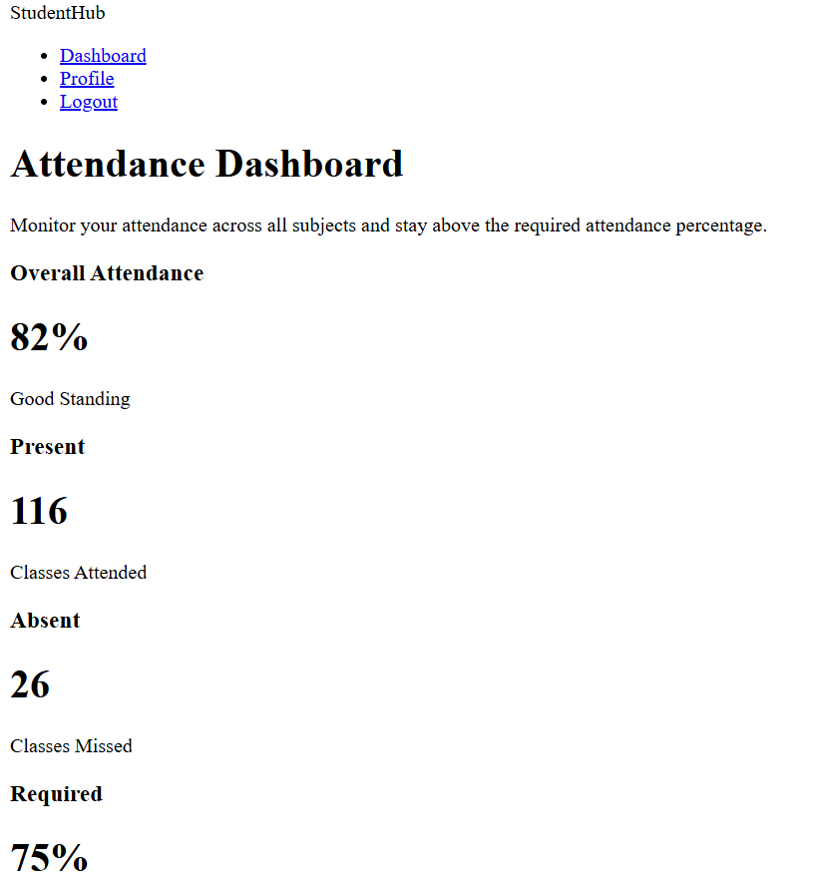
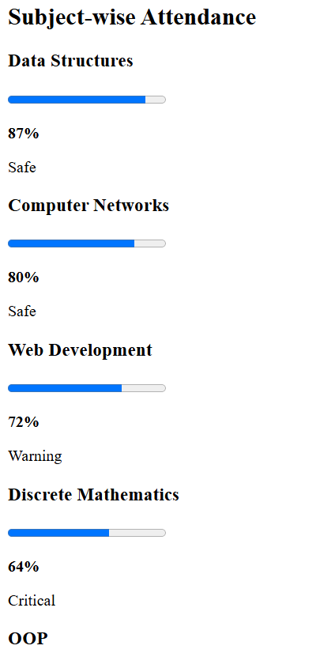
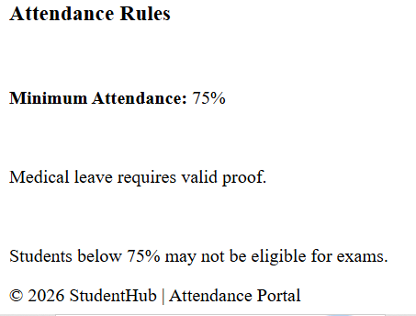
Description: This attendance page include reports of student’s attendance including progress bar
Figure 1.6 Certificate.html
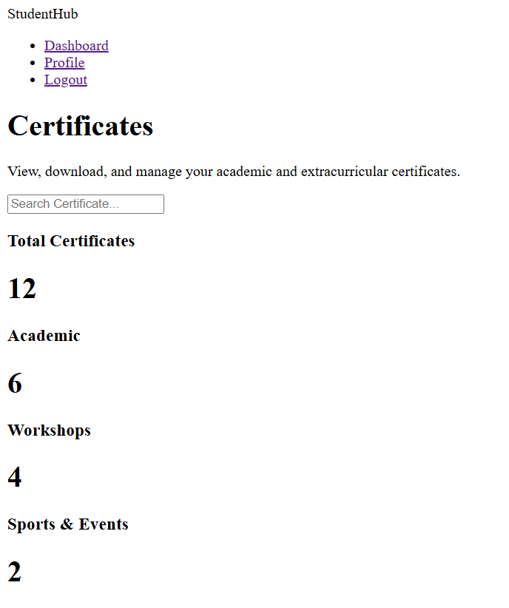
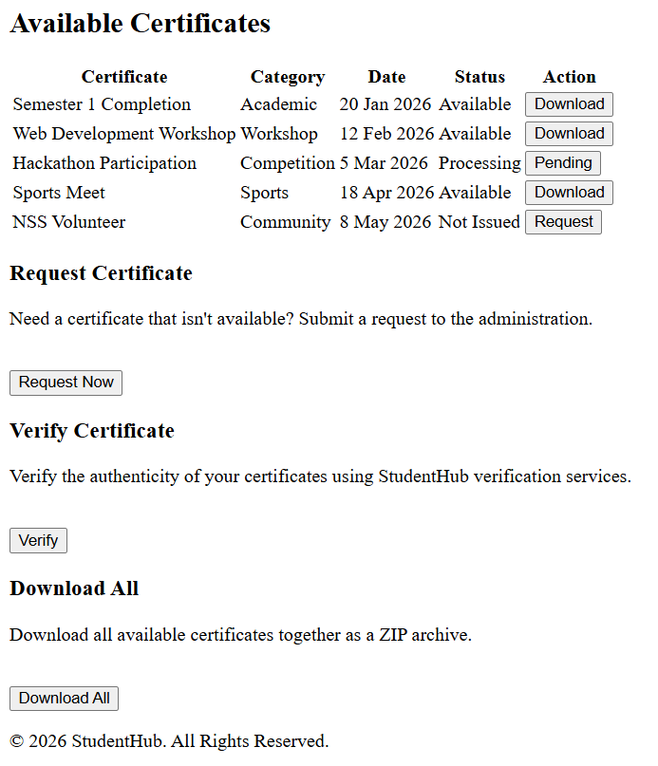
Description: This html page includes certificate download system for events that student had participated in

Figure 1.7 Fees.html
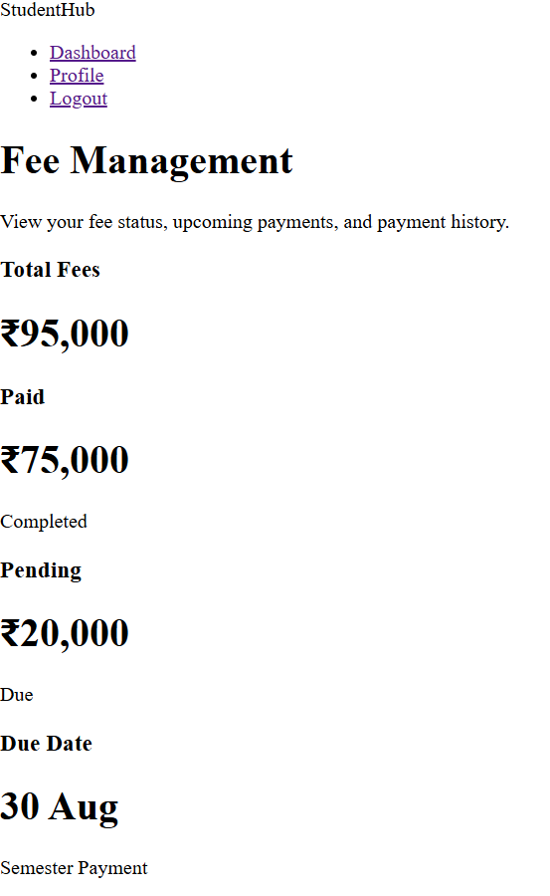
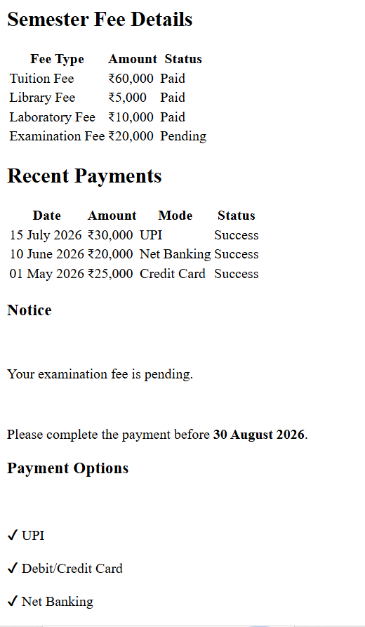
Description: fees.html contains fees details and recent payments of user
Figure 1.8 Events.html
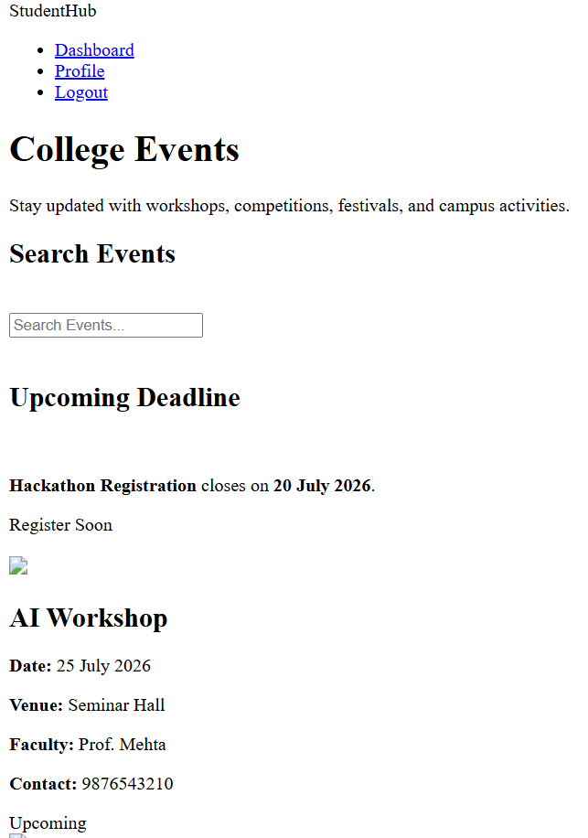
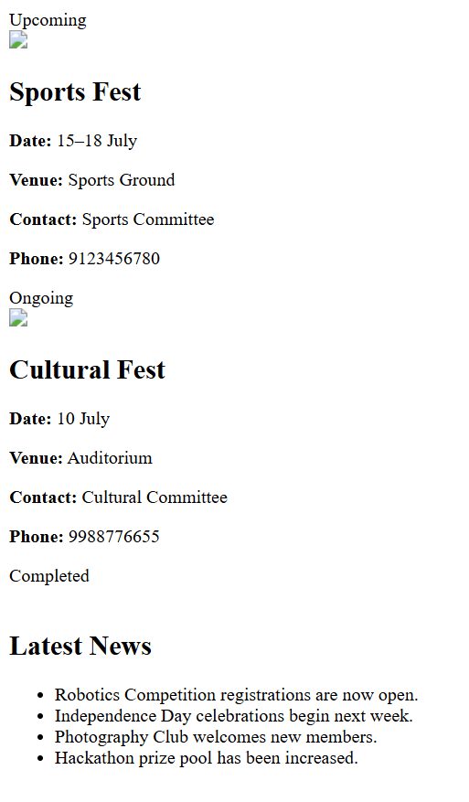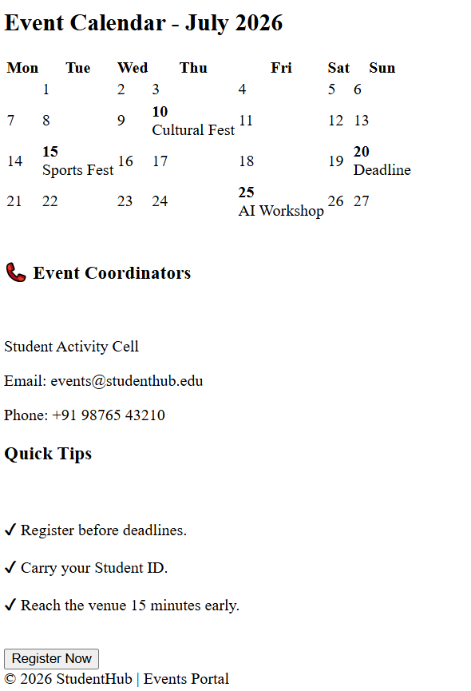
Description: Events page contains latest updates about events
Figure 1.9 result.html
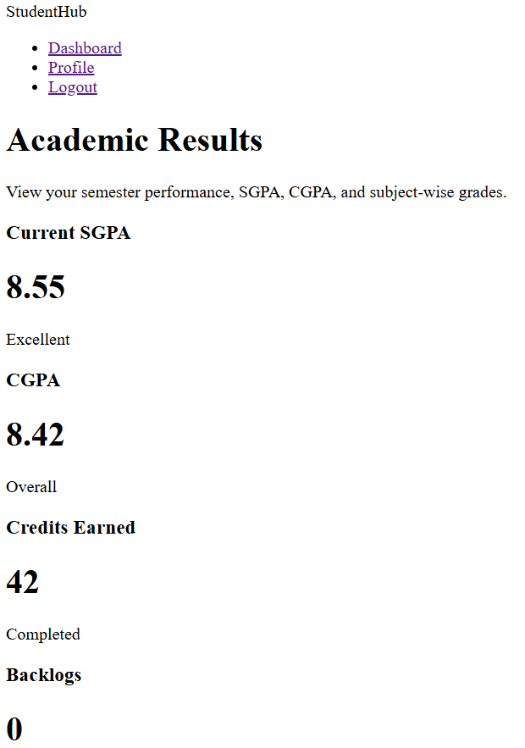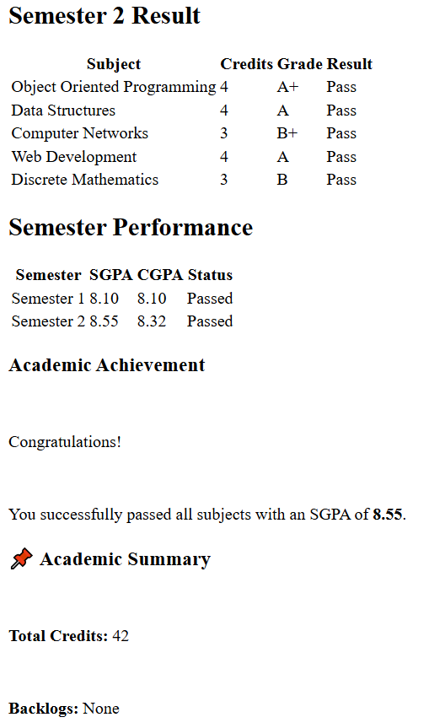
Description: This page contains student’s marksheet and results updates

GitHub Repository Link:
https://github.com/heerce27/StudentHub-Portal.git

Challenges Faced:

I faced problems like proper alignment of tables and different headings setting
I also faced problems while making a sidebar using an aside tag, as it kept being on other pages while hiding them.
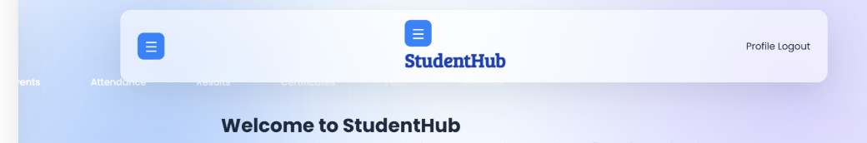
(sidebar was added after applying css .
Problem: It kept coming in horizontal style instead of vertical . )

Learning Outcomes:

I learned to use different html tags and made html pages using that for studenthub portal
Then I explored some solutions for it and found an overlay method.
Also learned about progress tag . It is used for showing progress in systems like we have for our phone’s brightness system.
I also learned how a sidebar is made using a aside tag, if you want to make one for all, js and live server will be needed but since i did not use live server for that, i added it in each page’s html.

Faculty Remarks:

